Interdisciplinarity and Cooperation in Cross Border Research
INTERNATIONAL SUMMER CONFERENCE
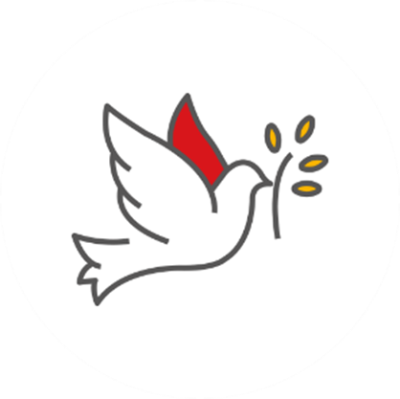 | 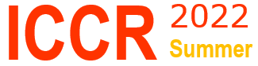

June 2nd to 4th, 2022 in Chișinău, Republic of Moldova
No Conference Fee

Programme ONSITE  Thursday, June 2nd, 2022  Conference 9:00 - 17:00  The welcome dinner at 18:00  Friday, June 3rd, 2022  Conference 10:00 - 18:00  The networking dinner at 19:00  Saturday, June 4th, 2022  Workshop 10:00 - 12:00 | Programme ONLINE  Thursday, June 2nd, 2022  Conference 9:00 - 17:00  Friday, June 3rd, 2022  Conference 10:00 - 18:00  Saturday, June 4th, 2022  Workshop 10:00 - 12:00
The organiser may change the programme.

Registration data

Name of conference participant | First name | FAMILY NAME
Company/ Organisation
Address
Phone number
E-mail
Participation | ORAL / POSTER

Title of the paper
title title title

First name FAMILY NAME

Organisation (Country)

E-mail

First name FAMILY NAME

Organisation (Country)

E-mail

First name FAMILY NAME

Organisation (Country)

E-mail

Abstract (maximum 250 words)
Abstract abstract abstract abstract abstract abstract abstract abstract abstract abstract abstract abstract abstract abstract abstract abstract abstract abstract abstract abstract abstract abstract abstract abstract abstract abstract abstract abstract abstract abstract abstract abstract abstract abstract abstract abstract abstract abstract abstract abstract abstract abstract abstract abstract abstract abstract abstract abstract abstract abstract abstract abstract abstract abstract abstract abstract abstract abstract abstract abstract abstract abstract abstract abstract abstract abstract abstract abstract abstract abstract abstract abstract abstract abstract abstract abstract abstract abstract abstract abstract abstract abstract abstract abstract abstract abstract abstract abstract abstract abstract abstract abstract abstract abstract abstract abstract abstract abstract abstract abstract abstract abstract abstract abstract abstract abstract abstract abstract abstract abstract abstract abstract abstract abstract abstract abstract abstract abstract abstract abstract abstract abstract abstract abstract abstract abstract abstract abstract abstract abstract abstract abstract abstract abstract abstract abstract abstract abstract abstract abstract abstract abstract abstract abstract abstract abstract abstract abstract abstract abstract abstract abstract abstract abstract abstract abstract abstract abstract abstract abstract abstract abstract abstract abstract abstract abstract abstract abstract abstract abstract abstract abstract abstract abstract abstract abstract abstract abstract abstract abstract abstract abstract abstract abstract abstract abstract abstract abstract abstract abstract abstract abstract abstract abstract abstract abstract abstract abstract abstract abstract abstract abstract abstract abstract abstract abstract abstract abstract abstract abstract abstract abstract abstract abstract abstract abstract abstract abstract abstract abstract abstract abstract abstract abstract abstract abstract abstract abstract abstract abstract abstract abstract abstract abstract abstract abstract abstract abstract abstract abstract abstract abstract abstract abstract abstract abstract abstract abstract abstract abstract abstract abstract abstract abstract abstract abstract abstract abstract abstract abstract abstract abstract abstract abstract.

Keywords: xxxxxxx, xxxxx, xxxxx, xxxxxx (3-5 words).
The registration form (in English) will be sent by 1.05.2022, to the e-mail address of the person in charge of the panel. The full papers will be sent by 15.06.2022, to the e-mail address of the person in charge of the panel.

Panels | Persons in charge
Physical education and sport | Asist. drd. Ciprian ZANFIR  e-mail: Ciprian.Zanfir@ugal.ro
Economy and international business | Lecturer dr. Alina SARACU  e-mail: Alina.Saracu@ugal.ro
Ecology and environment protection | Lecturer dr. Mugurel ENACHE  e-mail: Mugurel.Enache@ugal.ro
Agrifood | Lecturer dr. Veronica FILIMON  e-mail: Veronica.Filimon@ugal.ro
Advanced materials in engineering | Lecturer dr. Alina Mihaela Ceoromila  e-mail: Alina.Cantaragiu@ugal.ro

A selection of full papers (in English) will be published in
ACROSS – A Comprehensive Review of Societal Studies (BDI indexed).
https://kanalregister.hkdir.no/publiseringskanaler/erihplus/periodical/info?id=502415

